eGo User Guide

Version: 0.0.1
DocCode: E-Tools-ALL-UG-2010-0007
Date:October 21, 2010


www.spreadtrum.com
Important Notice
Copyright Notice
Copyright © 2010, Spreadtrum Communications, Inc. All rights reserved.
Trademarks
Spreadtrum Communications, Inc. and Spreadtrum Communications, Inc.'s products are exclusively owned by Spreadtrum Communications, Inc. References to other companies and their products use trademarks owned by the respective companies and are for reference purpose only.
Warranty Disclaimer
Spreadtrum Communications, Inc. makes no representations or warranties, either expressed or implied, by or with respect to anything in this document, and shall not be liable for any implied warranties of merchantability or fitness for a particular purpose or for any indirect, special or consequential damages.
Confidentiality
The information contained herein (including any attachments) is confidential. The recipient hereby acknowledges the confidentiality of this document, and except for specific purposes, this document shall not be disclosed to any third party.
About This Document

Purpose
The SPRD8800 User Guide describes how to use SPRD8800.

Intended Audience

Organization
This document consists of five chapters and is organized as follows.
Chapter | Describes
1 Introduction | File composition and running requirements of SPRD8800.
2 Interface Description | The main interface, toolbar, and status area of SPRD8800.
3 Quick Start | How to start the program, set the parameters, download the software, and quit the program.
4 Basic Operations | Basic operations such as dial-up, sync data and etc.
5 Advance Operations | Advance operations of engineer setting.
6 Configure File | Introduce the configure file.

Contents
1 Introduction 4
1.1 System Overview 4
1.2 File Composition 4
2 Interface Description 5
2.1 Main User Interface 5
2.2 Sub User Interface 6
2.2.1 System-Info User Interface 6
2.2.2 Dial-up User Interface 8
2.2.3 Sync Information User Interface 8
2.2.4 Voice Business User Interface 9
2.2.5 Engineer User Interface 10
2.2.6 Configuration User Interface 11
2.3 Menu 12
2.3.1 System 12
2.3.2 Service 13
2.3.3 Help 13
2.3.4 Tray Icon Right Click Menu 14
2.4 Toolbar 14
2.5 Status Bar 15
3 Quick Start 16
3.1 Prepare 16
3.2 Running the Program 16
3.3 Dial-up 16
4 Basic Operations 18
4.1 Checking PIN 18
4.1.1 Introduction of PIN and PUK 18
4.1.2 How to check PIN 18
4.2 Dial-up 19
4.2.1 Connect 19
4.2.2 Disconnect 21
4.3 Data sync 21
4.3.1 Short Message (SMS) 21
4.3.2 Phone Book (PB) 27
4.3.3 Save sync data 29
4.3.4 Open sync data 29
4.4 Voice Business 30
4.4.1 Operation 30
4.4.2 Phone Record 31
4.5 Configuration 31
4.5.1 Select Network 31
4.5.2 Dial Up 32
4.5.3 Security 33
4.5.4 Dual-Mode 36
4.5.5 Others 37
4.6 Help 38
5 Advance Operations 39
5.1 Engineering Mode 39
5.1.1 PDP Context 39
5.1.2 Business Rate 40
5.1.3 Lock/Unlock Frequency 40
5.1.4 PS Attach Setting 41
5.1.5 Item Setting 42
5.1.6 UE Identity 43
5.1.7 UPLMN 44
5.1.8 Dual-Mode 45
5.1.9 AT Cmd 46
5.1.10 DSP 47
6 Configure File 49

Figures
Figure 2-1 Main user interface on the disconnected state 5
Figure 2-2 Main user interface on the connected state 6
Figure 2-3 System-Info user interface 7
Figure 2-4 Dial-up user interface 8
Figure 2-5 Sync information user interface 9
Figure 2-6 Voice Business User Interface 10
Figure 2-7 Engineer User Interface 11
Figure 2-8 Configuration user Interface 12
Figure 2-9 System menu 12
Figure 2-10 Service menu 13
Figure 2-11 Help menu 13
Figure 2-12 Tray icon menu 14
Figure 2-13 Toolbar 14
Figure 2-14 Status area 15
Figure 3-1 Service menu 16
Figure 3-2 Dial-up user interface 17
Figure 3-3 Try icon menu 17
Figure 4-1 Inputting PUK1 19
Figure 4-2 Dial-up user interface 20
Figure 4-3 Dial-up successful interface. 21
Figure 4-4 Preset SMS dialog 22
Figure 4-5 Preset SMS new dialog 23
Figure 4-6 Preset SMS dialog with items. 23
Figure 4-7 Short messages load completely 24
Figure 4-8 SMS dialog 25
Figure 4-9 Select num dialog 25
Figure 4-10 Select preset SMS dialog 26
Figure 4-11 SMS center dialog 27
Figure 4-12 Phone book load completely 28
Figure 4-13 Phone book dialog 28
Figure 4-14 Call 30
Figure 4-15 Coming Call 30
Figure 4-16 Select Network 32
Figure 4-17 Dial Up 33
Figure 4-18 Security 34
Figure 4-19 Modify PIN1 35
Figure 4-20 Unlock of PIN1 35
Figure 4-21 Modify of PIN2 36
Figure 4-22 Unlock of PIN2 36
Figure 4-23 Dual-Mode 37
Figure 4-24 Others 38
Figure 5-1 PDP Context 39
Figure 5-2 Business Rate 40
Figure 5-3 Lock/Unlock Frequency 41
Figure 5-4 PS Attach Setting 42
Figure 5-5 Item Setting 43
Figure 5-6 UE Identify 44
Figure 5-7 UPLMN 45
Figure 5-8 Dual-Mode 46
Figure 5-9 AT Cmd 46
Figure 5-10 DSP 48

Tables
Table 1-1 File composition 3
Table 2-1 Dial-up user interface introduction 6
Table 2-2 System menu introduction 7
Table 2-3 Service menu introduction 8
Table 2-4 Help menu introduction 8
Table 2-5 Tray icon menu introduction 8
Table 2-6 Toolbar icons introduction 9
Table 2-7 Columns in the status area 9
Table 5-1 Table 24

Introduction

System Overview
SPRD8800 is used to check system information, dial-up, sync data such as short message, phone book and phone group, audio operation and setting.

File Composition
eGo consists of the files described in Table 1-1.
                - File composition
Type | File
*.exe | SPRD8800.exe
*.dll | EtionU.dll  ResEnU.dll  SCIMemoU.dll  SCIPBU.dll  SCIPBGroupU.dll  SciPortU.dll  SCIShortMsgU.dll  SciUartComm.dll
Configuration file | SPRD8800.ini  Channel.ini
Pdb file | SCIPBGroupU.pdb  SCIShortMsgU.pdb  SciPortU.pdb  SPRD8800.pdb  EtionU.pdb  ResEnU.pdb  SCIMemoU.pdb  SCIPBU.pdb

Interface Description

Main User Interface
If the device is not connected, the main user interface likes Figure 2-1, otherwise likes Figure 2-2.
              - Main user interface on the disconnected state
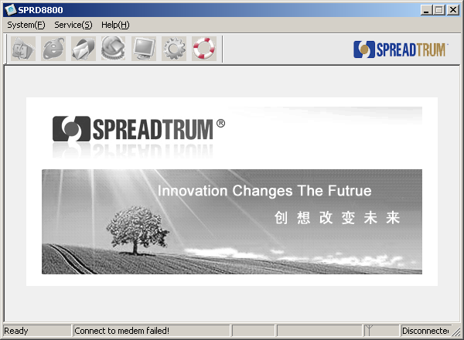
              - Main user interface on the connected state
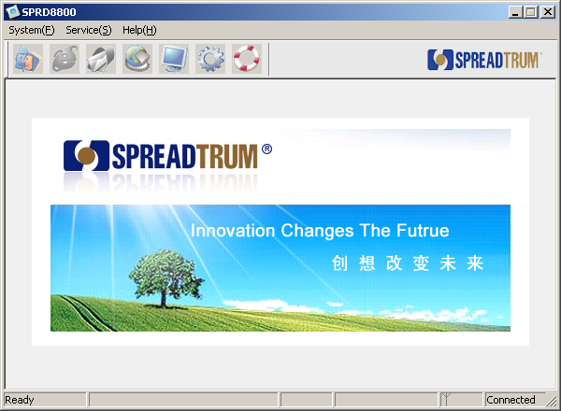

Sub User Interface

System-Info User Interface
[System-Info] is showed as Figure 2-3. It is used to show system information.
              - System-Info user interface
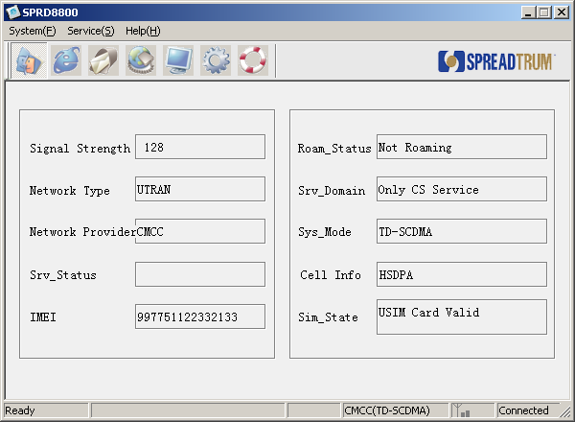
The introduction is showed as 2.2.2 Table 2-1.
                - System-Info user interface introduction
Item | Description
Signal Strength | Signal of cell service.
Network Type | Type of network.
Network Provider | Provider of network.
Srv_status | Status of service
IMEI | IMEI.
Roam_Status | Status of roam.
Srv_Domain | Service Domain
Sys_Mode | System Mode.
Cell Info | Information of cell.
Sim_State | State of SIM card

Dial-up User Interface
[Dial-up] is showed as Figure 2-1. It is used to dial-up to access Internet.
              - Dial-up user interface
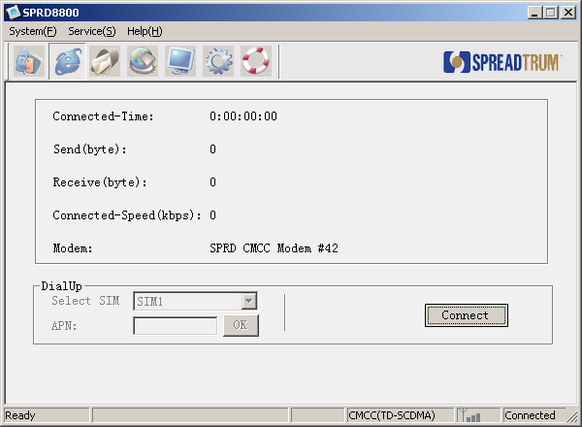
The introduction is showed as Table 2-1.
                - Dial-up user interface introduction
Item | Description
Connected-Time | It shows the time when you dial-up succeed until you disconnect.
Send(byte) | It shows the quantity of data sent since you dial-up succeeded.
Received(Byte) | It shows the quantity of data received since you dial-up succeeded.
Connected-Speed(kbps) | It shows the speed of data stream.
Modem | Modem name.

Sync Information User Interface
[Sync Information] provides a set of operation for short message and phone book. It is showed as Figure 2-1.

              - Sync information user interface
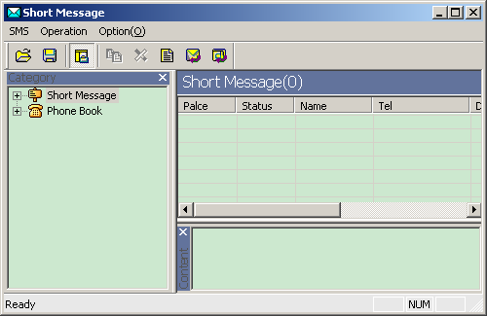

Voice Business User Interface
[Voice Business] is showed as Figure 2-1. It is used to call and answer some calling.
              - Voice Business User Interface
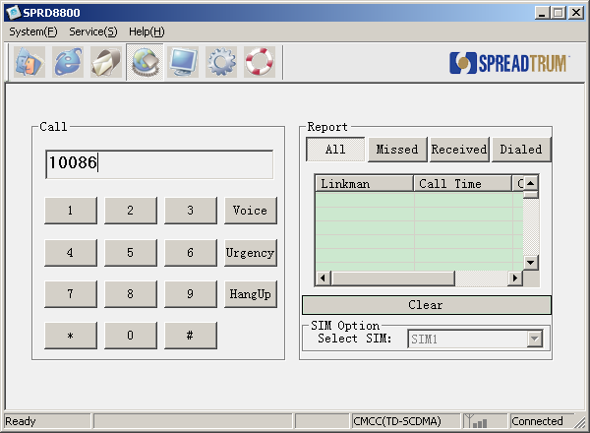
The introduction is showed as Table 2-1
                - Voice Business user interface introduction
Item | Description
Edit for phone number | Show MOC or MTC number.
Keyword area | Click number and then it will be showed in phone number edit.
Phone record | Show phone record.
All | All record of phone.
Missed | Missed record of phone.
Received | Received record of phone.
Dialed | Dialed record of phone.
SIM option | Only valid for dual-SIM card.

Engineer User Interface
[Engineer] is showed as Figure 2-1. It is used to configure advance. parameter.
              - Engineer User Interface
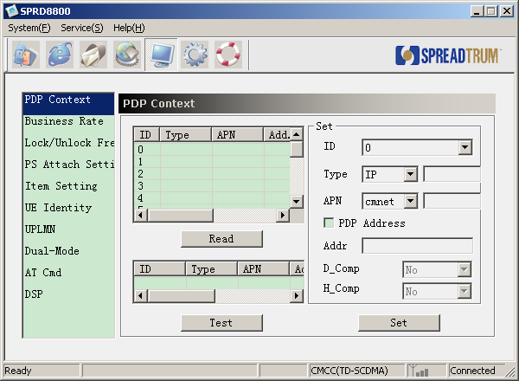
[Engineer] User Interface include many sub interface, refer to 5.1.

Configuration User Interface
[Configuration] is showed as Figure 2-1. It is used to configure some parameter.
              - Configuration user Interface
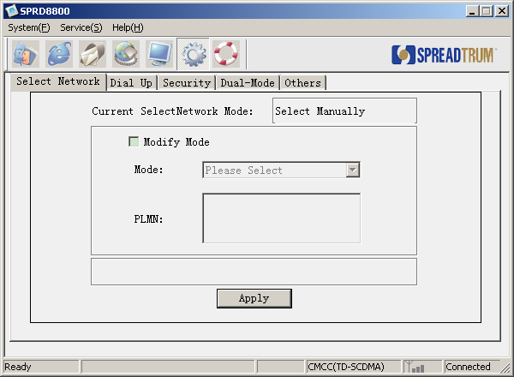
[Configuration] User Interface include many sub interface, refer to 4.5.

Menu

System
[System] menu showed as Figure 2-1 and its items are described as Table 2-1.
              - System menu
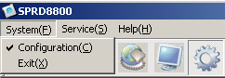
                - System menu introduction
Item | Description
Exit | Exit the program.

Service
[Service] menu showed as Figure 2-1 and its items are described as Table 2-1.
              - Service menu
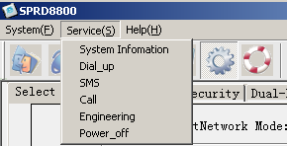
                - Service menu introduction
Item | Description
System Information | Open System-Info interface
Dial-up | Dial-up to access Internet
SMS | Sync Information
Call | Voice Business
Engineering | Engineer parameter configure
Power_off | Power off the device

Help
[Help] menu showed as Figure 2-1 and its items are described as Table 2-1.
              - Help menu
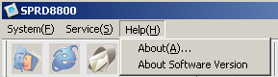
                - Help menu introduction
Item | Description
About | Display version information dialog
About Software version | Display software version of device

Tray Icon Right Click Menu
[Tray Icon Menu] menu showed as Figure 2-1 and its items are described as Table 2-1.
              - Tray icon menu
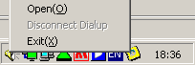
                - Tray icon menu introduction
Item | Description
Open | Show the Main user interface on the desktop
Disconnect Dial-up | Disconnect the Internet
Exit | Exit the program.

Toolbar
Toolbar is showed as Figure 2-1 and its items are described as Table 2-1.
              - Toolbar
                - Toolbar icons introduction
Icon | Description
 | Show System-Info user interface
 | Show dial-up user interface
 | Show sync information use interface
 | Show Voice Business
 | Show engineer interface
 | Show configure interface
 | Show version information dialog

Status Bar
The status bar is showed as Figure 2-1 and its items are described as Table 2-1.
              - Status area
                - Columns in the status area
Column | Description
a | Operation tips.
b | Runtime information.
c | Signal
d | Connect state

Quick Start

Prepare
First, make sure that modem driver was installed on your PC, and it works normally.
Second, make sure that mobile phone was connected with your PC by USB line.。
Note:
Make sure that there existed at least one SIM card in your mobile phone; otherwise eGo can not connect with the mobile phone.

Running the Program
Click the eGo.exe file in the folder of eGo tool installed. eGo will connect the mobile phone automatically. When connected, the yellow icon will be showed on the system bar.

Dial-up
Here will introduce the shortcut steps to dial-up access Internet. The detailed steps can be found in.
Click menu “Service”-> “Dial-up”, see Figure 3-1:
              - Service menu
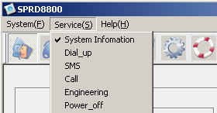
Or click the button  on the tool bar to enter the “Dial-up” interface, see Figure 3-2:
              - Dial-up user interface
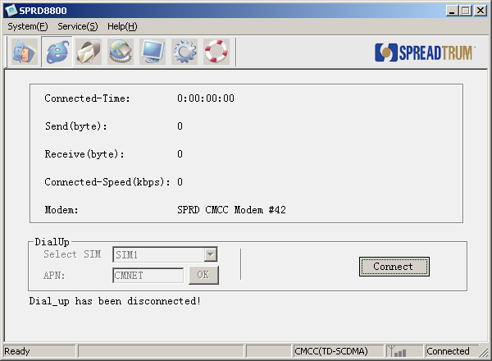
Click the button “Connect” to dial-up. At the same time, Dial-up process will be showed under this interface.
Note:
There will be many dialogs in the dial-up process, please follow them.

When dial-up connected, the icon will be showed on the right-bottom corner of your PC screen. Click the minimized button and the tool will be showed as a green icon on the right-bottom corner of your PC screen.
When you want to disconnect the internet, you can right click the icon and show the menu, see Figure 3-3, and then click “Disconnect”. Click the “Open” on this menu, and the tool interface will show on the desktop. Click “exit” on this menu, you can close and exit the tool.
              - Try icon menu
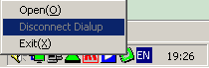

Basic Operations

Checking PIN

Introduction of PIN and PUK
1. PIN is the personal identify password of SIM card. Before modify, it is 1234 by default. If it is not correct, do not try again, please ask it from some professional people. If PIN is opened, you need to input it when the phone is opened.. There are only three times for you to input, after three times, PIN will be locked, you need use PUK to unlock it. PUK is provided by CMCC or CUCC, before modify, it is 12345678 by default. There are only ten times for you to input, after ten times, this SIM card is invalid.
2. PIN2 is used when setting account of phone. Before modify, it is 4321 by default. There are only three times for you to input, after three times, PIN2 will be locked, you need to use PUK2 to unlock it. Before modify, it is 87654321 by default. There are only ten times for you to input, after ten times, this SIM card is invalid.

How to check PIN
After the device is connected to PC and PIN is open, at this time, opened “SPRD8800” tool, it will ask you to input PIN.
SPRD8800 will check the current status of SIM card by AT command; it may be one status of follow:
            - Needing to input PIN1;
            - Needing to input PUK1;
            - Do not need to input PIN or PUK.

If do not need to input anything, “SPRD8800 “ will show the main interface.

If need to input PIN1, then the dialog will be showed as Figure 4-1:
              - Input PIN1
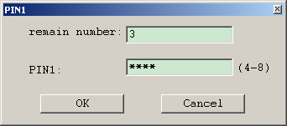
If need to input PUK1, then the dialog will be showed as Figure 4-2:
              - Inputting PUK1
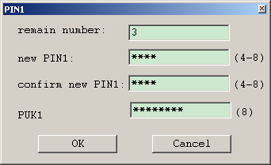
Notice:
When PIN or PUK input error, the “remain number” will less one, there are only three times for you to input PIN, after three times error, the PUK will be need to input to unlock PIN. After ten times error for PUK, this SIM card will be invalid.

Dial-up

Connect
[Dial-up] operation steps are as following:
Click “Connect” button to dial-up, see Figure 4-1.
              - Dial-up user interface
When connect successfully, the “Connect” button changes to “Disconnect” button, at the same time, the icon on the system tool bar changes green. “Connect time”, “Send data” and “Receive data” will be updated in real time, see Figure 4-2:
              - Dial-up successful interface.
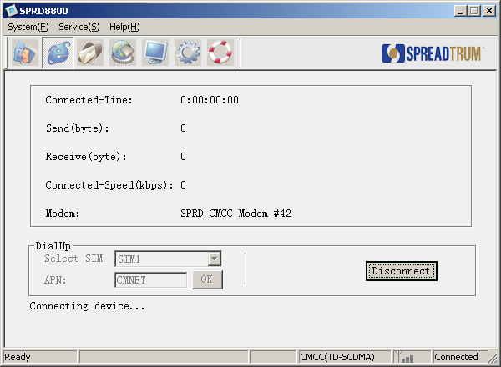
After connected, you can click the minimized button to make the tool show as an icon on the system bar. It will be convenient for surfing Internet. You can right click the icon, and a menu will be showed, and then you can select “Open” to display the tool on the desktop again.

Disconnect
There are tow ways to disconnect the Internet:
- Click the “Disconnect” button to disconnect the Internet.
- Right click the iconon the system bar and show the menu, and select “Disconnect” item to disconnect the Internet.

Data sync
Click the icon on the toolbar to show the data-sync user interface, see 2.2.3 Figure 2-1.

Short Message (SMS)
[SMS]Supply the following services:
- Preset short message
- Read short message
- Create new short message
- Edit short message
- Send short message
- Reply short message
- Forward short message
- Delete short message
- Query and set the number of SMS center
Detailed functions are as bellowing.
  - Reset short message
Select the menu [Option] -> [SMS ]-> [Preset SMS], or select the SMS on the left tree view and right click the right list view to show the menu and select [Preset SMS], and then the preset SMS dialog is showed as Figure 4-1:
              - Preset SMS dialog
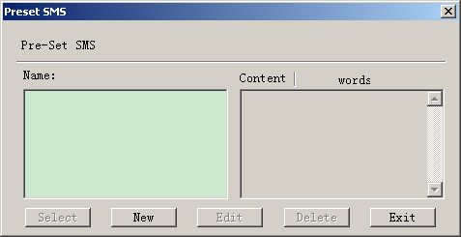
1）Click “New” button, the dialog changes as Figure 4-2:

              - Preset SMS new dialog
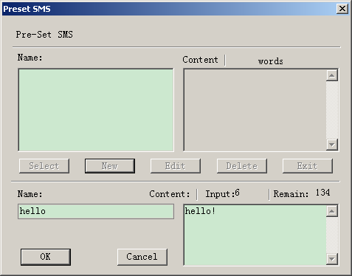
2）Input the information in the “Name” and “Content” edit box. And then click “OK” button to preset a short message, and then the interface is showed as Figure 4-3.
              - Preset SMS dialog with items.
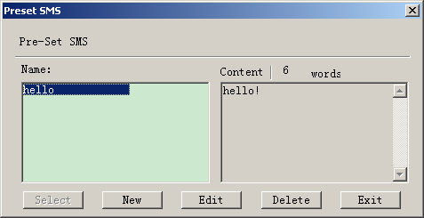
Note:
- You can only input 140 Latin characters or 70 other words (e.g. Chinese words).
- You can create multi preset-SMS
- When you select a preset-SMS, you can edit its content but not modify its name.
- [Select] button is invalid in this service.
- All preset-SMS are stored in the file “PresetSMS.dat”. If you delete this file, all preset-SMS are deleted too.
  - Read short message
Select the “Short Message” on the left tree view, and then click the icon to load short messages, or select the menu [Option] -> [Load] -> [SMS]. And the tool will load short messages from the mobile phone. The load process will be showed in the statues bar. After loading complete, a dialog will be showed to tell you loading complete. All short messages loaded from mobile phone will showed in the right list view as Figure 4-4. When you click one short message and its content will be showed in the “content” view.
              - Short messages load completely
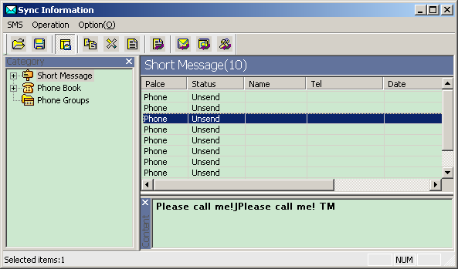
  - Create new short message
Right click the right list view and show the menu, and select [New] to show create new short message dialog as Figure 4-5:
              - SMS dialog
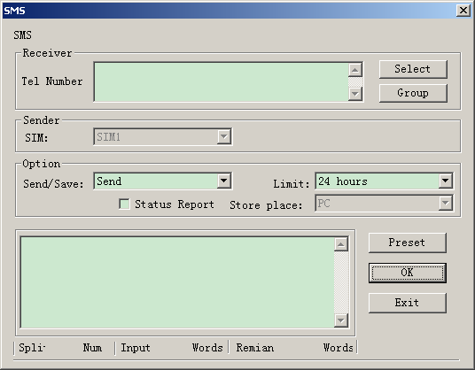
- Input the receiver phone number. You can input multi phone number and separate them with “;”. If you have load phone book from mobile phone, you can click the “Select” button to select phone number and the interface is showed as Figure 4-6.
              - Select num dialog
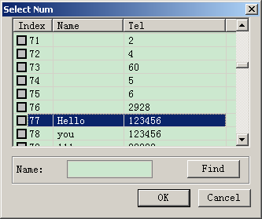
- Input the short message content. If you have preset-SMS, you can click “Preset” button to select preset short messages and the interface is showed as Figure 4-7.
              - Select preset SMS dialog
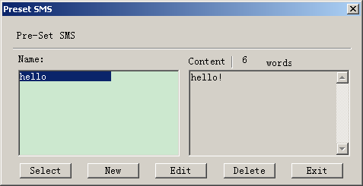
- Set the “Send/Save”, “Limit”, “Status report” options if necessary。
- If you have two SIM cards in the mobile phone, you need set the sender using which SIM card to send the SMS.
- Click “OK” button to send or save the current short message.

  - Edit short message
(1) Double click the short message in the right list view or right click the short message to show the menu, and select [Edit]. And then will show the SMS dialog.
（2）You can modify the short message as the “Create new short message” sector.
  - Send short message
Select the “Unsent” short message in the right list view, and right click to show the menu, and then select [Send] item to send this short message. When you create a new short message, you can click the “OK” button to send the new short message.
  - Reply short message
Select the short message in the right list view, and right click to show the menu, and then select [Reply] item
Note:
You can only reply the short messages in the “Inbox”.
You can not modify the receiver phone number.

  - Forward short message
Select the short message in the right list view, and right click to show the menu, and then select [Forward] item
Note:
You can only reply the short messages in the “Outbox”.
You can not modify the short message content.

  - Delete short message
Select the short messages in the right list view, and right click to show the menu, and then select [Delete] item.

  - Query and set the number of SMS cent
Select menu [Option] -> [SMS] -> [Center Number], and show a dialog as Figure 4-8:
              - SMS center dialog
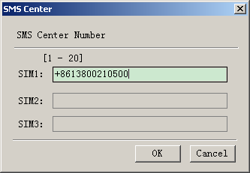
eGo will query the center number from mobile phone and display them. If you want reset them, modify the number and click “OK” button.
Note:
SMS center number is provided by your mobile operator.
Max length is 20.
Valid characters are “0”-“9” and “+#*abcABC”.

Phone Book (PB)
[PB]Supply the following services:
  - Read phone book
  - Create new phone book
  - Edit phone book
  - Delete phone book
  - Export VCARD
  - Import VCARD
Detailed functions are as bellowing
  - Read phone book
Select the “Phone book” on the left tree view, and then click the icon to load phone book, or select the menu [Option] -> [Load] -> [PhoneBook]. And the tool will load phone book from the mobile phone. The load process will be showed in the statues bar. After loading complete, a dialog will be showed to tell you loading complete. All phone book items loaded from mobile phone will showed in the right list view as Figure 4-1.
              - Phone book load completely
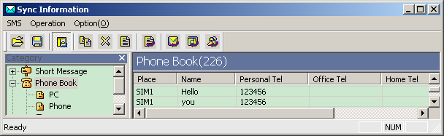

  - Create new phone book
Right click the right list view and show the menu, and select [New] to show create new phone book dialog as Figure 4-2:
              - Phone book dialog
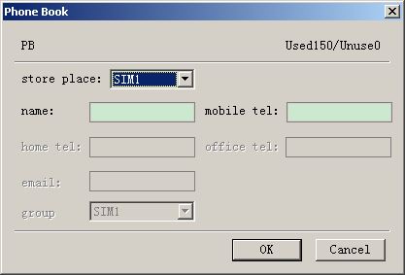
  - Select store place
  - Input the content as instruct of the interface
  - Click “OK” button to save the phone book item to the store place.

  - Edit phone book
(1) Double click the phone book item in the right list view or right click it to show the menu, and select [Edit]. And then will show the “Phone Book” dialog.
（2）You can modify the phone book item as the “Create new phone book” sector.

  - Delete phone book
Select the phone book items in the right list view, and right click to show the menu, and then select [Delete] item.

  - Export VCARD
Select the phone book items in the right list view, and right click to show the menu, and then select [Export VCard] item, and then will show a dialog to select a folder to save them.
Note:
The VCARD file name is same as the phone name.

  - Import VCARD
Right click the right list view to show the menu, and then select [Import VCard] item, and then will show a dialog to select VCARD files.

Save sync data
Select menu [File] -> [Save]. It will save the sync data to your PC.
Note:
This will save the SMS, PB and PB Group data to your PC.
Before saving the sync data, you must execute the sync operation for SMS, PB or PB Group.

Open sync data
Select menu [File] -> [Open]. It will open the sync data from your PC.

Voice Business

Operation
In this function, “SPRD8800” supports three operations: Call, Hold-On, Hang-Up.
            - Call

“SPRD8800” only support “Voice Call” now, input phone number and click “Call”, which is showed as Figure 4-1:
              - Call

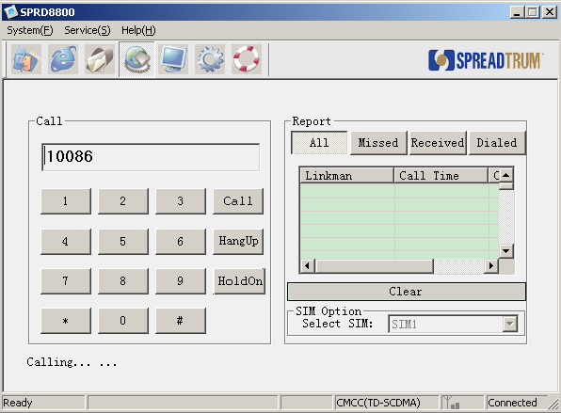

            - Hold-On

When calling is coming, if “SPRD8800” is working in the “Voice Business” interface, the icon in the right-bottom corner of PC will always flash until the user hold on the coming call. At this time, the interface of [Voice Business] is showed as Figure 4-1:
              - Coming Call

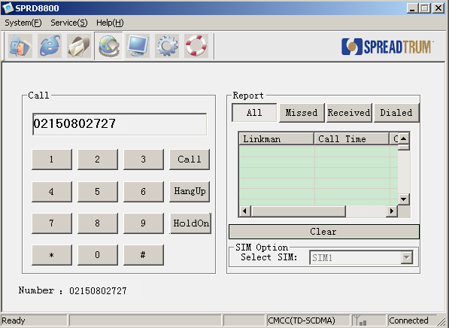
When call is coming, but “SPRD8800” is working in other interface, the icon in the right-bottom corner of PC will always flash, until the user double click it, and then the interface will change to [Voice Business] to convenience user to hold on.

            - Hang-Up

Both MOC and MTC can de hanged up by click “Hang-Up” button.

Phone Record
Phone record includes “All”, “Missed”, “Received” and “Dialed”. User can look over them by click “All”, “Missed”, “Received” and “Dialed” button in the interface.

Configuration

Select Network
[Select Network] interface is shown as Figure 4-1:
              - Select Network
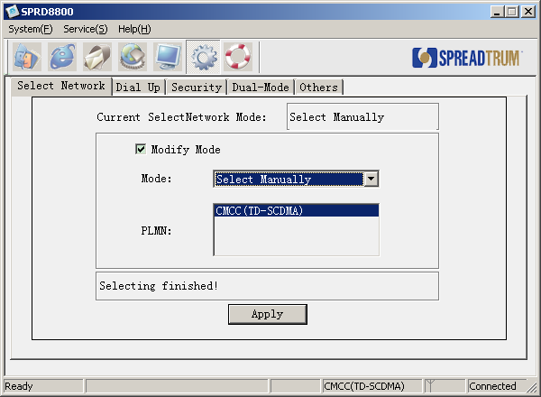
When first enter this interface, “SPRD8800” will check “current Select-Network Mode” automatically.
If need to change the mode, operated as bellow:
First, select “Modify Mode” check box.
Second, select one mode in “Mode” combo box. If user selects “Select Manually”, “SPRD8800” will search the network automatically and list them in the “PLMN” list. Selecting one PLMN and then click “Apply” button to valid it. If user selects “Select Automatically”, then click “Apply” button directly to valid it.

Dial Up
[Dial Up] interface is shown as Figure 4-1:
              - Dial Up
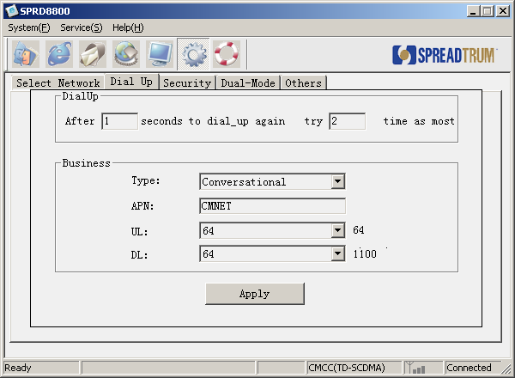
When first enter this interface, “SPRD8800” will check current “Type”, “APN”, “UL” and “DL” automatically, and display them in the interface. If need to change them, you can edit them in the “Business” edit and click “Apply” to valid them.

Security
[Security] interface is shown as Figure 4-1:
              - Security
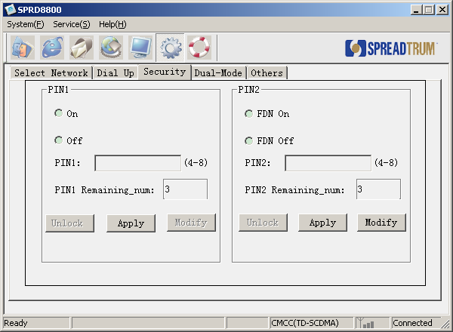
[Security] interface includes operation of PIN1, PIN2, and FDN.

1. PIN1
1．Setting of PIN1
When first enter this interface, “SPRD8800” will check the current status of PIN1 automatically and display it in the interface.
If need to change the status of PIN1, operated as bellow:
First, select “On” or “Off”;
Second, input the right PIN1, the length is 4-8;
Third, click “Apply” button to valid it. If inputting error password, “PIN1 Remaining-num” will less one. There are only three times to input it, after three times, the button of “Unlock” will be active.
Note:
“Modify” button will be active only when PIN1 with in the status of “On”.

2．Modify of PIN1
When PIN1 with the status of “On”, you can modify PIN1 by click “Modify” button, the dialog is shown as Figure 4-2:
              - Modify PIN1
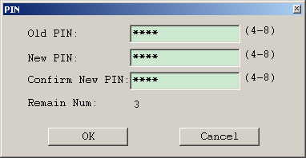

3．Unlock of PIN1
When input error PIN1 over three times, the SIM card will be locked, you need PUK1 to unlock it. Click “Unlock” button, the dialog will be shown as Figure 4-3:
              - Unlock of PIN1
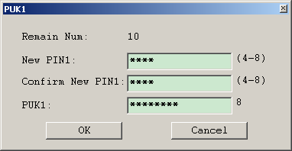
Note:
There are only ten times for inputting PUK1, after ten times, this SIM card is invalid.

2. PIN2
1．Setting of FDN
When first enter this interface, “SPRD8800” will check the current status of FDN automatically and display it in the interface.
If need to change the status of FDN, operated as bellow:
First, select “On” or “Off”;
Second, input the right PIN2, the length is 4-8;
Third, click “Apply” button to valid it. If inputting error password, “PIN2 Remaining-num” will less one. There are only three times to input it, after three times, the button of “Unlock” will be active.
Note:
“Modify” button will be active only when PIN1 with in the status of “On”.
2．Modify of PIN2
              - Modify of PIN2
3．Unlock of PIN2
When input error PIN2 over three times, the SIM card will be locked, you need PUK2 to unlock it. Click “Unlock” button, the dialog will be shown as Figure 4-5:
              - Unlock of PIN2
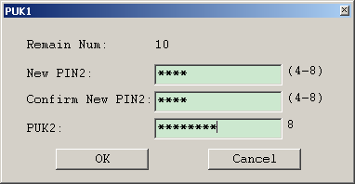
Note:
There are only ten times for inputting PUK2, after ten times, this SIM card is invalid.

Dual-Mode
[Dual-Mode] interface is shown as Figure 4-1:
              - Dual-Mode
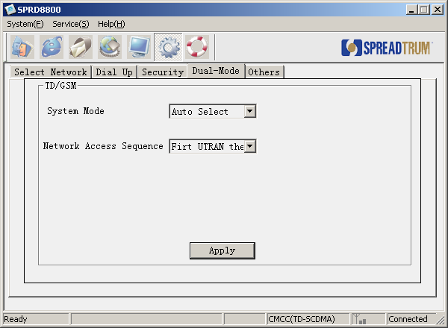
In this interface, you can configure “System Mode” and “Network Access Sequence”.
When enter this interface at first, “SPRD8800” will check current “System Mode” and “Network Access Sequence” automatically and display them in the interface.
If need to modify “System Mode” or “Network Access Sequence”, please select it in combo box and click “Apply” to valid them.

Others
[Others] interface is shown as Figure 4-1:
              - Others
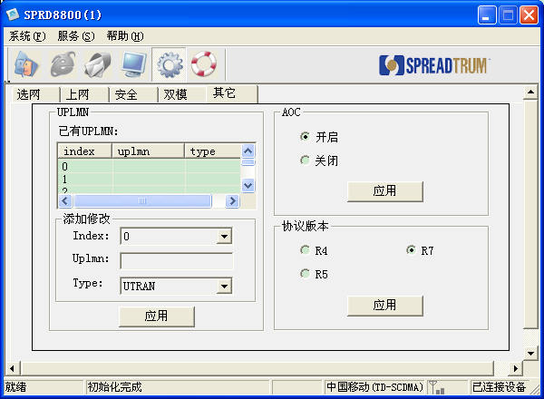
In this interface, you can configure “UPLMN”, “AOC” and “Version”.
When enter this interface at first, “SPRD8800” will check current “UPLMN”, “AOC” and “Version”, and display them in the interface.
If need to modify or add “UPLMN”, then input correct content in the “UPLMN” edit and click “Apply” to valid it.
If need to modify the status of “AOC”, then select “On” or “Off”, and click “Apply” to valid it.
If need to modify the status of “Version”, then select “R4”, “R5” or “R7”, and click “Apply” to valid it.

Help
Click the icon on the tool bar, you will see the version of eGo.

Advance Operations

Engineering Mode

PDP Context
[PDP Context] supports to modify the parameters of PDP, the interface is shown as Figure 5-1:
              - PDP Context
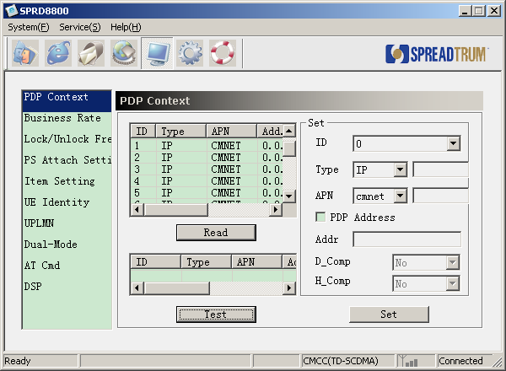
By click “Read” button, you can read the current PDP Context.
By click “Test”, you can check the range of parameters.
If need to modify or add new PDP context, you can edit the parameters in the “Set” option and click “Set” to valid it.
The means of the parameters in the “Set” option is as bellow:
1. ID: Identify of PDP context. range: 1-15
2. Type: Type of PDP context. Only support IP now. If select “Other”, some type name need to be input in the right edit.
3. APN: Only support “cmnet” and “cmwap” now. If select “Other”, some APN name need to be input in the right edit.
4. Addr: Only valid when select “PDP Address”. This item can be empty, network will assign a IP address automatically.
5. D-Comp: Only valid when select “PDP Address”. 0: not compress; 1: compress.
6. H-Comp: Only valid when select “PDP Address”. 0: not compress; 1: compress.

Business Rate
In this interface, you can configure up-link and down-link rate for some business. The interface is shown as Figure 5-1:
              - Business Rate
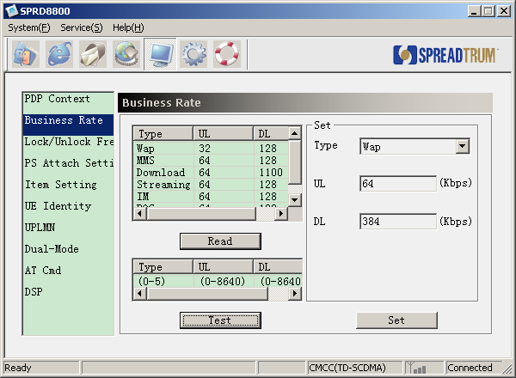
By click “Read” button to read up-link and down-link rate of all business.
By click “Test” button to check the range of parameters.
If need to modify the up-link or down-link rate of some business, you can modify the parameters in the “Set” option, and click “Set” to valid it.

Lock/Unlock Frequency
This interface supports to lock or unlock frequency. The interface is shown as Figure 5-1:
              - Lock/Unlock Frequency
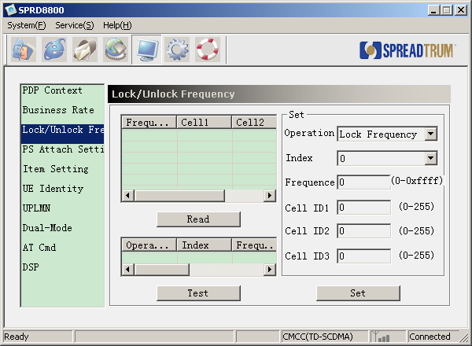
By click “Read” button to read the information of all frequency.
By click “Test” button to check the range of the parameters.
If need to modify the frequency, you can modify the parameters in the “Set” option.
The means of parameters in the “Set” option is as bellow:
1. Operation: Lock/Unlock.
2. Index: Index of frequency. Range: 0-3.
3. Frequency: Range: 0-0xffff
4. Cell ID1: Range: 0-255
5. Cell ID2: Range: 0-255
6.Cell ID3: Range: 0-255

PS Attach Setting
This interface is shown as Figure 5-1:
              - PS Attach Setting
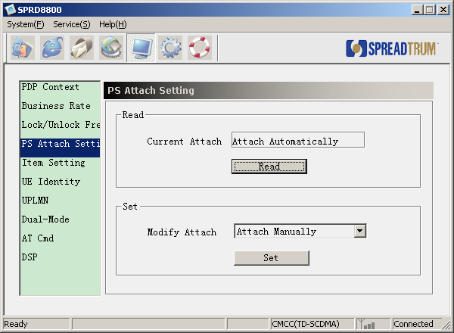
By click “Read” button to read “Current Attach”.
If need to change “Attach Mode”, you can select it in combo box, and click “Set” to valid it.

Item Setting
This interface supports to set test item option. The interface is shown as Figure 5-1:
              - Item Setting
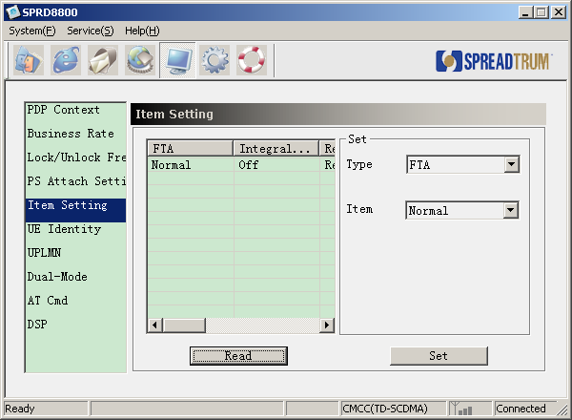
By click “Read” button to read the current status of item.
If need to modify the status of item, you can edit them in the “Set” option and click “Set” to valid it.

UE Identity
This interface is shown as Figure 5-1:
:
              - UE Identify
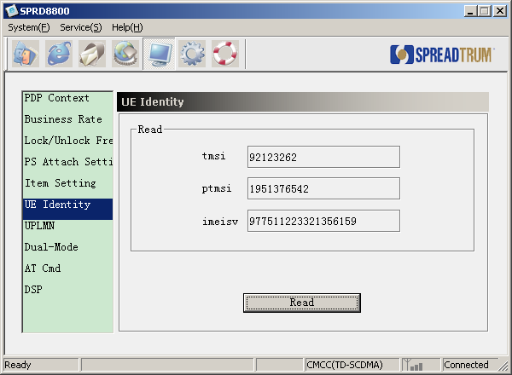
Click “Read” button to get information of UE.

UPLMN
This interface is shown as Figure 5-1:
              - UPLMN
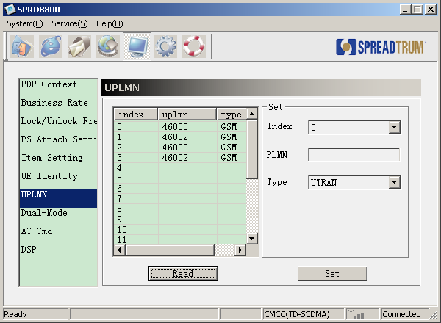
By click “Read” button to read current “UPLMN”.
If need to modify the information of “UPLMN”, you can modify the item in the “Set” option.
The means of the parameters in the “Set” option is as bellow:
1. Index: Range: 0-20.
2. PLMN: Identify of uplmn, for example, “46007” and so on.
3. Network type: UTRAN or GSM.

Dual-Mode
This interface is shown as Figure 5-1:
              - Dual-Mode
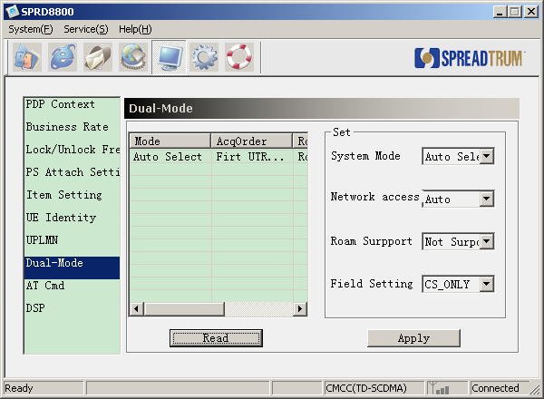
By click “Read” button to read current information.
If need to modify the parameters, you can edit them in the “Set” option, and click “Apply” to valid it.
The means of the parameters in the “Set” option is as bellow:
1. System Mode: “Auto Select”, “GSM ONLY”, “WCDMA ONLY”, “TDSCDMA ONLY” or “NO Change”.
2. Network Access: “Auto”, “First GSM then UTRAN”, or “First UTRAN then GSM”.
3. Roam Support: “Not Support”, “Roam”, or “No Change”.
4. Field Setting: “CS_ONLY”, “PS_ONLY”, “CS_PS”, or “No Change”.

AT Cmd
This interface is shown as Figure 5-1:
              - AT Cmd

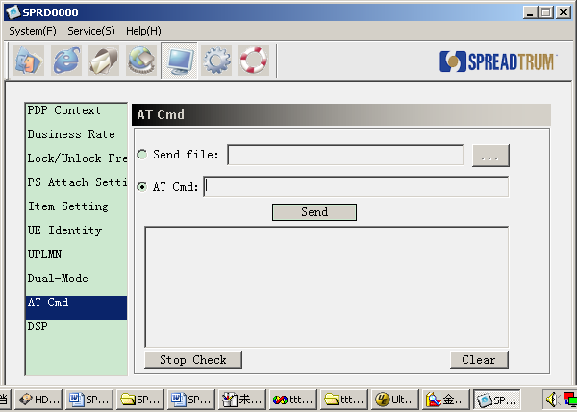
This interface support two modes of sending AT.
1. Send AT by file. Browse some file at “Send file”, and then click “Send” button to send them. The respond will be listed in the list box.
2. Edit AT command in the “AT Cmd”, and click “Send” button to send it, the respond will be listed in the list box.

DSP
This interface is shown as Figure 5-1:
              - DSP
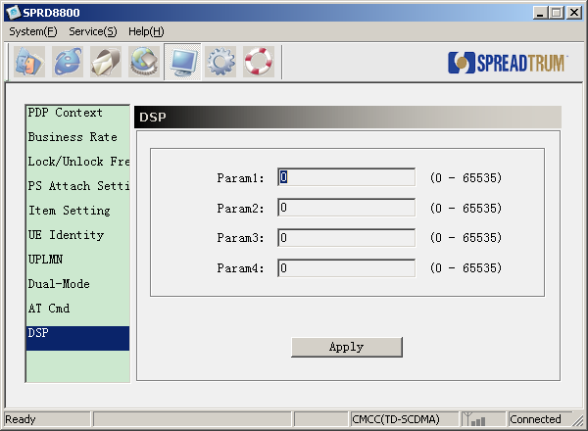

Input the content in the edit , and click “Apply” to valid it.

Configure File
“EGO.ini” is eGo configure file. It can be found in the folder of eGo installed. Its content is as following:

[Log]
Enable=1
[Net]
DialTime=1
DialNum=3
[PS Depatch]
Depatch=0
[Lang]
lang=0

[Page]
LoadAudioPage=1
[Window]
WindowID=1
Mutex=0

[Setting]
manual = 0
port = 12
baud = 115200

[DeviceBaudRate]
BaudRate = 115200

[DeviceCount]
Count=2

[DeviceGeneral1]
Device=SCI USBModem
[DeviceMux1]
DeviceSerCount=2
DeviceSer1=SCI VSerial1
DeviceSer2=SCI VSerial2
DeviceModCount=2
DeviceMod1=SCI VModem1
DeviceMod2=SCI VModem2

[DeviceGeneral2]
Device=SPRD CMCC Modem
[DeviceMux2]
DeviceSerCount=2
DeviceSer1=SPRD CMCC AT Interface1
DeviceSer2=SPRD CMCC AT Interface2
DeviceModCount=2
DeviceMod1=SPRD CMCC Modem
DeviceMod2=SPRD CMCC MMS

Parameters are introduced as Table 6-1:
                - Table
Sector | Description
Log | Enable = 1 means to generate “EGO_com.log” file to save the data communicated tool and mobile phone.  Enable = 0 not to generate the log file.
Net | DialTim = 1 means to redial after 1 second if dial-up failed.  DialNum = 3 means to redial 3 times if dial-up failed.
PS Depatch | Depatch = 1 means to PS Depatch
Page | Display “Voice Business” or not. LoadAudioPage=1, display; LoadAudioPage=0, not display.
Window | If need to open multi-window of “SPRD8800”, edit this item. Mutex=0, only open one; Mutex=1, open multi-window. WindowID, the identify of the window.
Lang | Lang=0 means the UI text is Chinese.  Lang=1 means the UI text is English.
Setting | Manual = 1 means the port and baud set is valid, and eGo will open this port.
DeviceBaudRate | BaudRate = 115200 means eGo will use the baud rate to communicate.
DeviceCount | Count=2 means the tool support two category devices. When the tool can not connect the first device, it will try to connect the next until succeed or all fail.
DeviceGeneralX | Device=SCI USBModem means the device name if not use MUX driver.
DeviceMuxX | This is for MUX driver.  DeviceSerCount = 2 means the MUX driver will generate to two virtual AT ports.  DeviceSer1and DeviceSer2 are the name of the two AT ports DeviceModCount = means the MUX driver will generate to two virtual modem ports.  DeviceMod1和DeviceMod2 are the name of the two modem ports

